English Vocabulary – Playing Cards

Two Three Four Five Six Seven Eight Nine Ten Jack Queen King Ace
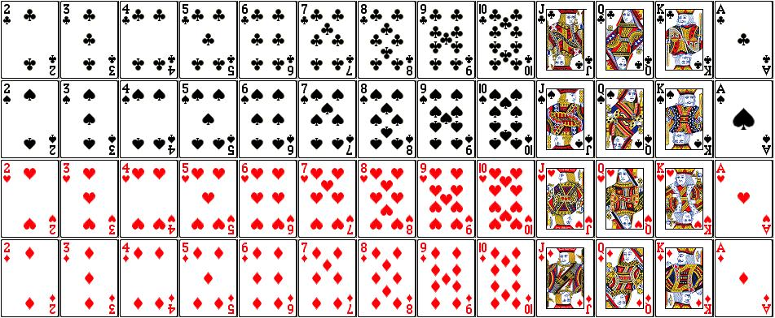

Clubs

Spades

Hearts

Diamonds

Other Vocabulary
suit ________________________ a round ________________________
hand ________________________ to bet on ________________________
player ________________________ a dummy hand ________________________
dealer ________________________ to deal the cards ________________________
winner ________________________ to shuffle the cards ________________________

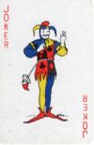
The card game “Newmarket”
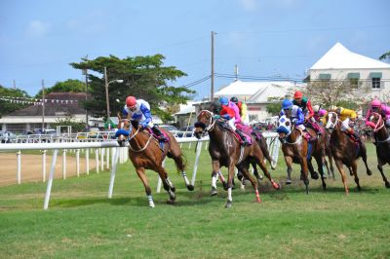
The object of the game is to win all the money on the table! A game for 4 to 8 players.

Preparation: 4 ‘horses’ (taken from a separate pack of cards) are placed in the center of the table,
and each player receives 9 coins.

To Play:
- Each player bets two coins on the horses and places one in the center (the ‘pot’).
- The dealer deals all the cards to all the players, and also creates a dummy hand.
- The player to the left of the dealer examines his hand and if he wishes, can swap it with the dummy hand. Once swapped, he can’t swap back.
- All players look at, and prepare, their hands: separate into suits (♦♣♥♠), ascending order (2 to ace).
- The player to the left of the dealer lays his lowest red card on the table in front of him, and says its number and suit.
- Whoever has the following card (in ascending order) also lays that card on the table in front of him, and says its number.
- This continues until the sequence is broken.
- The player who last laid a card on the table then lays his lowest black card on the table, and says its number and suit.
- Whoever has the following card (in ascending order) also lays that card on the table, and says its number.
- This continues until the sequence is broken.
- This process continues, alternating red, black, red, black, etc.
- If anybody lays a ‘horse’ on the table, he immediately collects the money on that horse, and play continues.
- If a player doesn’t have a red card, or a black card, to begin a new sequence, play passes to the next player to the left. If nobody has an appropriate colored card, the round finishes and the pot remains uncollected.

The End of a Round:
- The round finishes when someone lays his last card on the table. He is the winner of the round and collects the pot.
- All other money on horses remains on the table.
- Any player without money leaves the game.
- The game finishes when only one person has money. He is the winner of the game.
- The game can also finish after any round. The winner is the person with the most money.

